There are two green materials (S-type material on F-type material) in the first material area, and there are two yellow materials (S-type material on F-type material) in the fifth material area. A robot should move green materials to third construction area and yellow materials to first construction area, placing the F-type materials onto the foundation and the S-type materials onto them and go back to the zero position. The task is deemed complete if all the materials are set correctly and the robot stays at the zero position with the accuracy of at least 1.5 mm. Losing or lifting the materials (cubes) again is not allowed during the task. The task should be complete within 120 sec.

Initial scene:

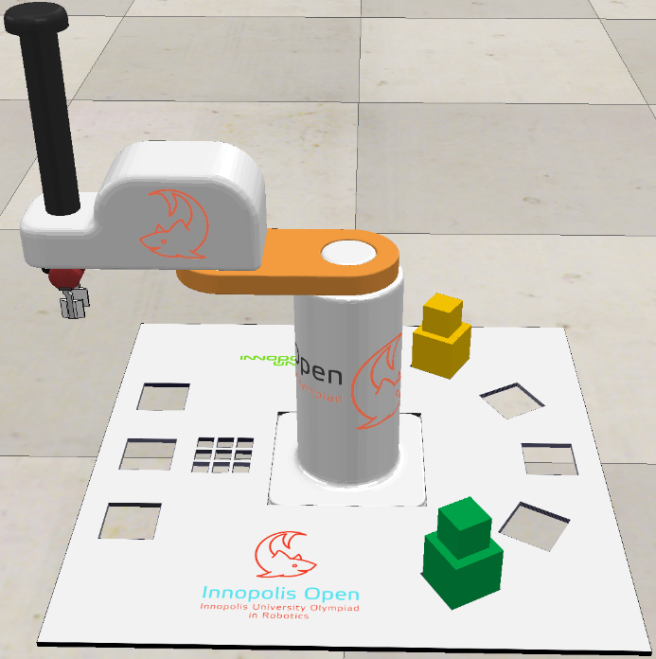

Complete task:

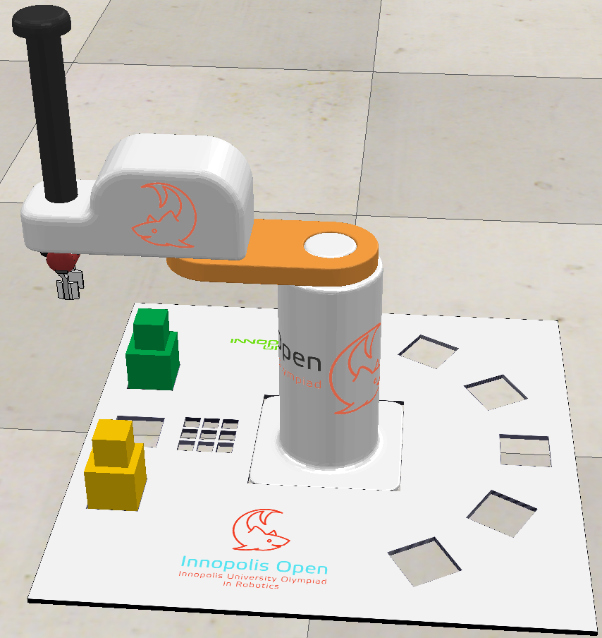

Three files with source code are accepted for answers:

- Child.lua – the source code of the program working in the asynchronous mode;

- Customization.lua - the source code of the program, working in the synchronous (step-by-step with the simulator) mode;

- ManIRS_senior.py – the source code of the robot control program in Python.

The program can be written in one of these files or in several files. The original versions of these files are located in the Programming/Lua and Programming/Python catalogues.